Nonagonal Rotunda
# Source: AI Source: Provided by: [Data Path: Persons Table -> ID Column: 1, Name_En Column: Motasem Essam] -> From: [ChatGPT] on [7/25/2026]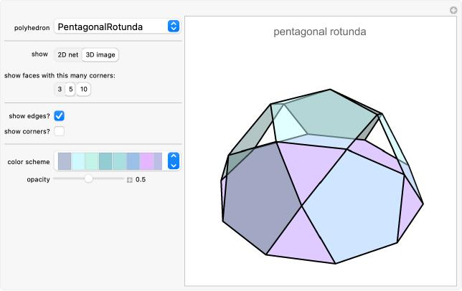

Definition
# Source: AI Source: Provided by: [Data Path: Persons Table -> ID Column: 1, Name_En Column: Motasem Essam] -> From: [ChatGPT] on [7/25/2026]
A Nonagonal Rotunda is a generalized rotunda-type polyhedron constructed with a nonagonal (9-sided) upper base and a parallel octadecagonal (18-sided) lower base.
Its lateral surface consists of alternating triangular and pentagonal faces arranged around the solid.
- 1 nonagonal upper base.
- 1 octadecagonal lower base.
- 18 triangular lateral faces.
- 9 pentagonal lateral faces.
The Nonagonal Rotunda follows the generalized rotunda construction. It is not one of the classical Johnson solids.

Geometric Structure
# Source: AI Source: Provided by: [Data Path: Persons Table -> ID Column: 1, Name_En Column: Motasem Essam] -> From: [ChatGPT] on [7/25/2026]
The structure is based on two parallel polygonal bases:
- Upper Base: A nonagon with 9 sides.
- Lower Base: An octadecagon with 18 sides, positioned parallel to the upper base and rotated relative to it.
- Lateral Surface: A band of 27 faces consisting of 18 triangles and 9 pentagons.
The triangular and pentagonal faces alternate around the lateral structure.

Face Composition
# Source: AI Source: Provided by: [Data Path: Persons Table -> ID Column: 1, Name_En Column: Motasem Essam] -> From: [ChatGPT] on [7/25/2026]
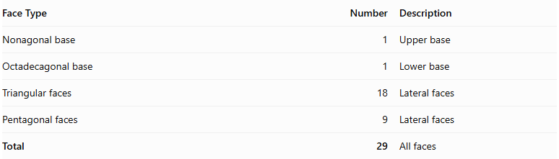
Face Type | Number | Description
Nonagonal base | 1 | Upper base
Octadecagonal base | 1 | Lower base
Triangular faces | 18 | Lateral faces
Pentagonal faces | 9 | Lateral faces
Total | 29 | All faces

Mathematical Properties
# Source: AI Source: Provided by: [Data Path: Persons Table -> ID Column: 1, Name_En Column: Motasem Essam] -> From: [ChatGPT] on [7/25/2026]
For a generalized rotunda with $n=9$:
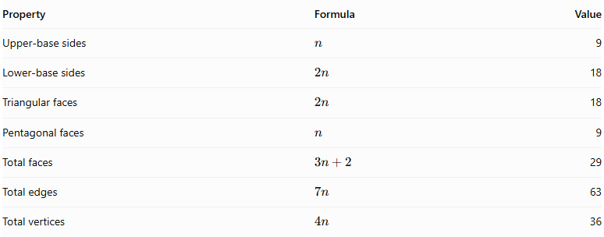
Property | Formula | Value
Upper-base sides | $$n$$ | 9
Lower-base sides | $$2n$$ | 18
Triangular faces | $$2n$$ | 18
Pentagonal faces | $$n$$ | 9
Total faces | $$3n+2$$ | 29
Total edges | $$7n$$ | 63
Total vertices | $$4n$$ | 36
Euler's Polyhedron Formula:
$$V-E+F=2$$
$$36-63+29=2$$
Therefore, the mathematical counts satisfy Euler's formula.

Geometric Characteristics
# Source: AI Source: Provided by: [Data Path: Persons Table -> ID Column: 1, Name_En Column: Motasem Essam] -> From: [ChatGPT] on [7/25/2026]
- Upper Base Shape: Nonagon.
- Lower Base Shape: Octadecagon.
- Lateral Face Types: Triangles and pentagons.
- Total Faces: 29.
- Total Edges: 63.
- Total Vertices: 36.
- Rotational Symmetry: Ninefold rotational symmetry.
- Convexity and Regularity: These depend on the particular geometric realization. The generalized construction does not require every face to be regular or all edges to have equal lengths.

Construction of Nonagonal Rotunda

Geometric Instruments Used
# Source: AI Source: Provided by: [Data Path: Persons Table -> ID Column: 1, Name_En Column: Motasem Essam] -> From: [ChatGPT] on [7/25/2026]
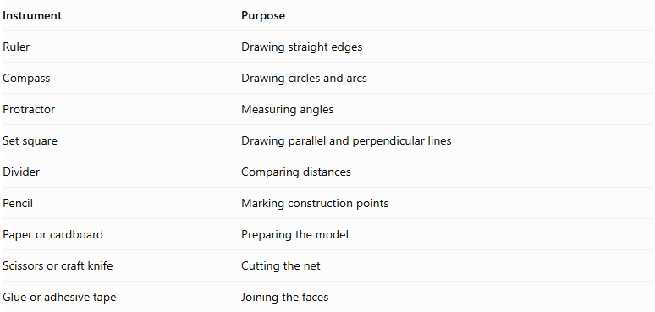
Instrument | Purpose
Ruler | Drawing straight edges
Compass | Drawing circles and arcs
Protractor | Measuring angles
Set square | Drawing parallel and perpendicular lines
Divider | Comparing distances
Pencil | Marking construction points
Paper or cardboard | Preparing the model
Scissors or craft knife | Cutting the net
Glue or adhesive tape | Joining the faces

Instrument-Based Construction Procedures
# Source: AI Source: Provided by: [Data Path: Persons Table -> ID Column: 1, Name_En Column: Motasem Essam] -> From: [ChatGPT] on [7/25/2026]
No coordinate-based construction is used.
The construction uses geometric instruments, measured lengths, angles, polygon geometry, and edge matching.
Important constructibility limitation: A regular nonagon and a regular octadecagon cannot be constructed exactly using only a compass and straightedge. A protractor-based measured construction or accurate templates are required.

A. Construct the Upper Regular Nonagonal Base
# Source: AI Source: Provided by: [Data Path: Persons Table -> ID Column: 1, Name_En Column: Motasem Essam] -> From: [ChatGPT] on [7/25/2026]
- Draw a circle using a compass.
- Mark its center.
- Divide the circumference into nine equal central angles.
- Each central angle measures:
$$\frac{{360}^{°}}{9}={40}^{°}$$
- Mark the nine points on the circumference.
- Join consecutive points using a ruler.
- Verify that the nine sides are approximately equal.
- Label the vertices.

B. Construct the Lower Regular Octadecagonal Base
# Source: AI Source: Provided by: [Data Path: Persons Table -> ID Column: 1, Name_En Column: Motasem Essam] -> From: [ChatGPT] on [7/25/2026]
- Draw a second circle using a compass.
- Mark its center.
- Divide the circumference into eighteen equal central angles.
- Each central angle measures:
$$\frac{{360}^{°}}{18}={20}^{°}$$
- Mark the eighteen points on the circumference.
- Join consecutive points using a ruler.
- Verify that the eighteen sides are approximately equal.
- Label the vertices.

C. Construct the Eighteen Triangular Lateral Faces
# Source: AI Source: Provided by: [Data Path: Persons Table -> ID Column: 1, Name_En Column: Motasem Essam] -> From: [ChatGPT] on [7/25/2026]
- Prepare eighteen triangular faces.
- Determine their side lengths and angles from the selected model.
- Arrange the triangles according to the intended lateral face pattern.
- Match their edges to the appropriate pentagonal faces and bases.
- Verify that each triangle fits its neighboring faces without gaps or overlaps.

D. Construct the Nine Pentagonal Lateral Faces
# Source: AI Source: Provided by: [Data Path: Persons Table -> ID Column: 1, Name_En Column: Motasem Essam] -> From: [ChatGPT] on [7/25/2026]
- Prepare nine pentagonal faces.
- Determine their side lengths and interior angles.
- Arrange the pentagons alternately within the lateral face arrangement.
- Match their edges with the neighboring triangular faces.
- Verify that the nine pentagons complete the lateral structure correctly.

E. Arrange the Faces
# Source: AI Source: Provided by: [Data Path: Persons Table -> ID Column: 1, Name_En Column: Motasem Essam] -> From: [ChatGPT] on [7/25/2026]
- Position the nonagonal upper base and octadecagonal lower base parallel to each other.
- Arrange the eighteen triangles and nine pentagons between the two bases.
- Check the lengths of all shared edges.
- Verify the intended ninefold rotational arrangement.
- Confirm that every edge belongs to exactly two faces and that the surface closes without gaps or overlaps.

F. Assemble the Solid
# Source: AI Source: Provided by: [Data Path: Persons Table -> ID Column: 1, Name_En Column: Motasem Essam] -> From: [ChatGPT] on [7/25/2026]
- Prepare a verified construction net or separate face pieces.
- Add joining tabs if using paper or cardboard.
- Cut out the faces.
- Fold the required edges.
- Join the matching lateral faces.
- Attach the upper nonagonal base and lower octadecagonal base.
- Inspect the completed model from several directions.
Construction accuracy: The nine pentagons and eighteen triangles must have dimensions and angles compatible with the selected generalized model. Simply using regular pentagons, equilateral triangles, a regular nonagon, and a regular octadecagon does not guarantee a valid closed Nonagonal Rotunda.

Key Points
# Source: AI Source: Provided by: [Data Path: Persons Table -> ID Column: 1, Name_En Column: Motasem Essam] -> From: [ChatGPT] on [7/25/2026]
- The Nonagonal Rotunda has a 9-sided upper base and an 18-sided lower base.
- Its lateral surface contains 18 triangles and 9 pentagons.
- It has 29 faces, 63 edges, and 36 vertices.
- It has ninefold rotational symmetry.
- It is a generalized rotunda, not a classical Johnson solid.

Main Classification
# Source: AI Source: Provided by: [Data Path: Persons Table -> ID Column: 1, Name_En Column: Motasem Essam] -> From: [ChatGPT] on [7/25/2026]
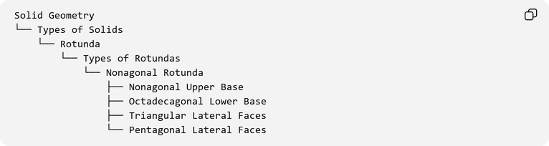
Solid Geometry
└── Types of Solids
└── Rotunda
└── Types of Rotundas
└── Nonagonal Rotunda
├── Nonagonal Upper Base
├── Octadecagonal Lower Base
├── Triangular Lateral Faces
└── Pentagonal Lateral Faces

Conclusion
# Source: AI Source: Provided by: [Data Path: Persons Table -> ID Column: 1, Name_En Column: Motasem Essam] -> From: [ChatGPT] on [7/25/2026]
The Nonagonal Rotunda is a generalized rotunda-type polyhedron with a nonagonal upper base, an octadecagonal lower base, and an alternating arrangement of triangular and pentagonal lateral faces. Its topology gives it 29 faces, 63 edges, and 36 vertices, with ninefold rotational symmetry.

